**P2 - “Rewilding” Initiatives**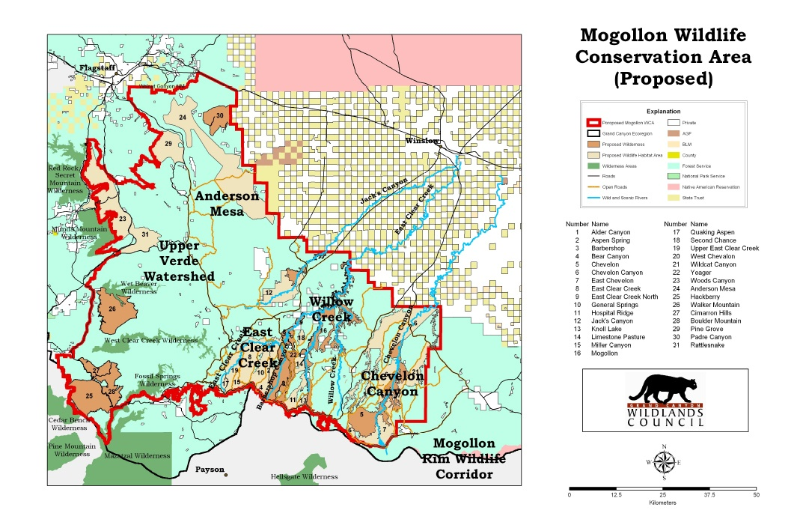

Major aspect here would be site identification - want high amnt of abandoned farmlands, underutilized landscapes, and fragmented habitats. However, I think private landowners (farmers) and local communities have a huge portion of sway.

Flevoland - pretty much doggerland 2. Oostvaardersplassen paleolithic park filled with animals such as Heck cattle*, Red Deer, Foxes, geese, egrets, and horses. Visitors now pay up to $45 to take safari tours in the park. Every year, tens of thousands of acres of farmland are taken out of production - why not use this land to produce “new nature” to replace what’s been lost? Depopulated expanses of the American Midwest are also candidates for ‘rewilding’. Frans Vera is Responsible for the Oostvaardersplassen, first became interested in idea in 1970s - read article about some Greylag geese who had appeared in the reclaimed area, and kept the vegetation low by eating it, maintaining their marshy habitat. At the time, prevailing view in Netherlands was that nature was something to be managed like a farm - preserve needed to planted, pruned and mowed. Vera thought if grazers were brought back, preserve could continue itself.

Would really need to take into account more case-by-case parameters for each rewilding initiative - range and behavior of animals, population density, climate, and whether or not land is govt. Owned (existing political tensions, think of zimov) - study fragmentation, energy w/in patches, and ecological status of given forest patch vis-à-vis neighbouring land uses etc.

Keep in mind biotic pump hypothesis: despite covering only about ~3% of Earth’s land surface, peatlands store more carbon per hectare than any other terrestrial ecosystem - totalling over 600 gigatonnes globally. While their productivity is lower than that of tropical forests, they store substantial carbon in both biomass and soils. Boreal forests, covering 17% of Earth's land surface, contain more than 30% of all terrestrial carbon.

[check this out] - **The work done at Indian Institute of Remote Sensing in development of standard methodology to assess forest at landscape level (**[https://www.sciencedirect.com/science/article/pii/S157495412200372](https://www.sciencedirect.com/science/article/pii/S1574954122003727) **)**

* Rewilding Europe Foundation: Focuses on areas like the Danube Delta, Transylvanian Alps, Eastern Carpathians, and Western Iberian Peninsula. Much more region-specific challenges and perhaps more difficult info to gather, but a bit more momentum already here (<https://conbio.onlinelibrary.wiley.com/doi/10.1111/cobi.12533>)
* North American Rewilding Projects: Organizations such as the *American Prairie Reserve* and *Rewilding Institute* are actively involved in rewilding efforts and can offer valuable data and collaboration opportunities. (<https://geospatialworld.net/article/spatial-decision-support-system-for-biodiversity-conservation/>)

*(check out initiatives on the mogollon wildway: <https://rewilding.org/the-mogollon-wildlife-corridor/> )

Rewilding Europe foundation - create giant versions of Oostvaardersplassen, east at leaft 15x as large. Group chose 5 regions to serve as what it calls “model rewilding areas” - a part of the danube delta, transylvanian alps, areas in the eastern carpathians, mountains of croatia, and western Iberian peninsula. Areas all that have few people. Idea is to connect existing reserves with tracts of abandoned land and working farms whose owners can be persuaded to let aurochs wander across their property.

| data? |  |
| --- | --- |
| Landcover data:   * *Corine Land Cover (CLC)*: Provides detailed land cover information across Europe, useful for identifying abandoned lands and natural habitats. * *National Land Cover Database (NLCD)*: Offers comprehensive land cover data for the U.S., aiding in identifying potential rewilding sites. * [Russian Federation - Cropland NDVI (VIIRS)](https://ipad.fas.usda.gov/cropexplorer/imageview.aspx?regionid=rs) * [SOIL SERIES (RHB/RFH/DJE)](https://soilseries.sc.egov.usda.gov/OSD_Docs/R/RUSSIAN.html) | (might want to check out marxan and terrset, both of which are used in designing reserve networks) |
| Protected Areas, Biod., Species Distribution:   * *Global Biodiversity Information Facility (GBIF)*: A repository of species occurrence data worldwide. * *European Environment Agency (EEA) Biodiversity Data Centre*: Data on species and habitats across Europe (need to find spec. though). |  |
| THIS MODEL???: ([Chazdon et al., 2016](https://www.sciencedirect.com/science/article/pii/S1574954122003727#bb0060); [Felicani Robles, 2015](https://www.sciencedirect.com/science/article/pii/S1574954122003727#bb0110)). |  |

*TLDR, boreal forests aid peat formation (Ополье)and reduces the direct solar radiation reaching the ground in summer months, however, allow for warmer overall winter months due to increased insulation. Herbivore-driven snow compaction and greater wind exposure exposes the permafrost to colder air during winter, and sees increased summer thawing. Frankly, I’m not sure if this issue is so cut-and-dry (lol).*

*Yakutsk, Sakha, Krasnoyarsk republic

1. Ramon J. Robben. "The Viability of Pleistocene Rewilding: Sound Conservation, or Another Attempt at Novelty?" Ecology & Evolution: Conservation Ecology, MSc Essay, University of Groningen, 2019, <https://fse.studenttheses.ub.rug.nl/21173/1/mEE_2019_RobbenRJ.pdf>
2. Rubenstein, Dustin R., Daniel I. Rubenstein, and Paul W. Sherman. "Pleistocene Park: Does re-wilding North America represent sound conservation for the 21st century?" Biological Conservation, vol. 132, no. 2, Oct. 2006, pp. 232–238, <https://doi.org/10.1016/j.biocon.2006.04.003>
3. Andersson, Kim, et al. "Climate Change May Increase Quebec Boreal Forest Productivity in High Latitudes by Shifting Its Current Composition." Frontiers in Forests and Global Change, vol. 6, 2023, <https://www.frontiersin.org/articles/10.3389/ffgc.2023.1020305/full>
4. Lorenzen, E. D., Nogués-Bravo, D., Orlando, L., Weinstock, J., Binladen, J., Marske, K. A., … Willerslev, E. (2011). Species-specific responses of Late Quaternary megafauna to climate and humans. Nature, 479 (7373), 359–364.
5. <https://doi.org/10.1038/nature10574>
6. Moss, Stephen. "The History and Legacy of Ice Age Rewilding in North America." Notes and Records: The Royal Society Journal of the History of Science, vol. 76, no. 1, 2021, <https://royalsocietypublishing.org/doi/10.1098/rsnr.2021.0032>

Tourists vs. ecologists vs. farmers